Exercise 6: Cursors
Scenario 1: Generate monthly statements for all customers.
o Question: Write a PL/SQL block using an explicit cursor GenerateMonthlyStatements that retrieves all transactions for the current month and prints a statement for each customer.
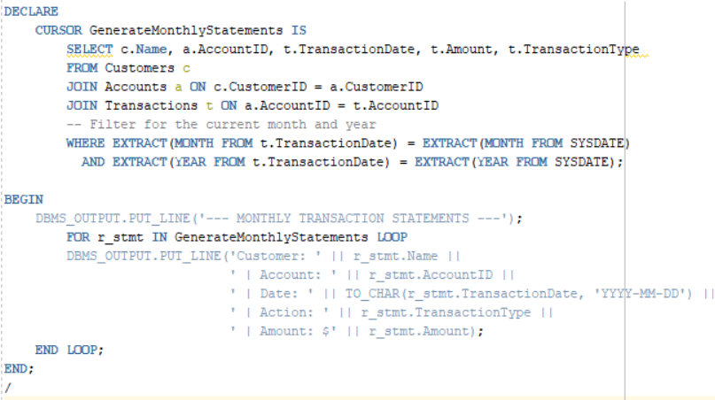
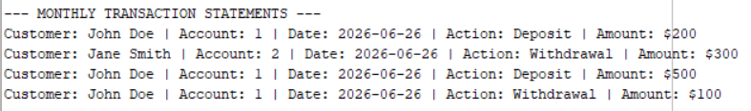

Scenario 2: Apply annual fee to all accounts.
o Question: Write a PL/SQL block using an explicit cursor ApplyAnnualFee that deducts an annual maintenance fee from the balance of all accounts.
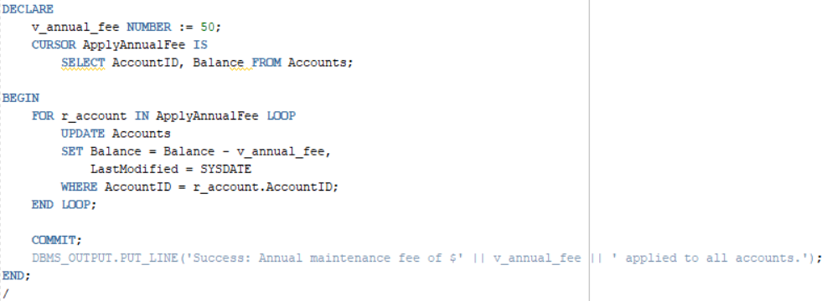

Scenario 3: Update the interest rate for all loans based on a new policy.
o Question: Write a PL/SQL block using an explicit cursor UpdateLoanInterestRates that fetches all loans and updates their interest rates based on the new policy.

